Catalyst Switch Lab: Small Office Network Build Guide
Oct 5, 2026 · Blake Otto

Overview
You'll build a two-switch small-office network on your real Catalyst switches, break it on purpose, and publish the configs, verification output and test results on GitHub. It proves two things at once: you can configure real Cisco hardware over a console cable, and you can explain what you built in writing.
The lab covers what entry-level networking interviews ask about: VLANs, 802.1Q trunking, LACP EtherChannel, Rapid PVST+, SSH-only management, DHCP, syslog and config backups. If one switch is Layer 3, it adds inter-VLAN routing.
Item | Notes
2 Catalyst switches | Already have them
Console cable | USB-to-RJ45 console cable, or a rollover cable plus a USB-to-serial adapter
Laptop | PuTTY (Windows) or screen (macOS/Linux) at 9600 baud
4 to 6 Ethernet cables | Two for the EtherChannel, the rest for test devices
Your Ubuntu server | Becomes the lab's syslog and TFTP backup server
Two rules before you start. Keep the lab off your home network: the lab runs its own DHCP, and a second DHCP server on your home LAN will break things for everyone in the house. And write notes as you go, including mistakes, because the troubleshooting log is the most convincing part of the final write-up.
First check: run show version on each switch. The model tells you whether it can route (a 2960 is Layer 2 only; a 3560, 3650, 3750 or 9300 can route), and the software line tells you whether it runs IOS or IOS XE. Phases 4 and 5 below depend on the answer.

Topology and addressing
SW1 acts as the core switch, STP root and (if it can route) the gateway for every VLAN; SW2 is the access switch your test laptop plugs into.
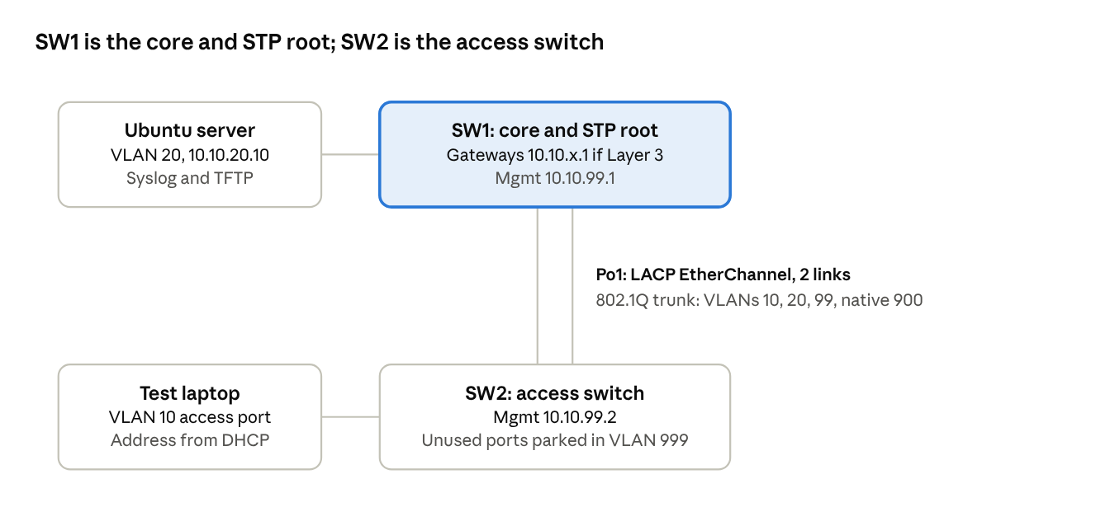
lab topology · 2 switches, 2 test devices
The two uplinks between the switches form one logical link, so pulling either cable should not drop traffic. If neither switch can route, move the server into VLAN 99 so everything shares one subnet.
VLAN | Name | Subnet | Gateway | Used for
10 | USERS | 10.10.10.0/24 | 10.10.10.1 (SW1) | Test laptop; DHCP leases from .21
20 | SERVERS | 10.10.20.0/24 | 10.10.20.1 (SW1) | Ubuntu server, static 10.10.20.10
99 | MGMT | 10.10.99.0/24 | 10.10.99.1 (SW1) | Switch management: SW1 .1, SW2 .2
900 | NATIVE | none | none | Trunk native VLAN, carries no hosts
999 | PARKING | none | none | Unused ports, shut down

Build phases
Each phase gives you the goal, how to tell it's working, and what to research. Working out the commands yourself is the point. Keep a running notes file of what you tried, what failed and what fixed it, because that becomes your troubleshooting log. Save the verification output after each phase for the GitHub repo.

Phase 0: Reset and inventory
Goal: record each switch's model, software version, Layer 2 or Layer 3 capability and port layout, then wipe the old configuration, including the saved VLAN database.
- Done when: both switches boot with no configuration and your inventory notes are saved.
- Research: how to fully erase a Catalyst switch, and the password recovery procedure for your model if an old password locks you out.

Phase 1: Secure baseline
Goal: each switch has a hostname, an encrypted privileged-mode password, a local admin account, a login on the console, a login banner, and remote access by SSH version 2 only, with Telnet disabled.
- Done when: the console asks for a username, and (after Phase 4) SSH works while Telnet is refused.
- Research: what a switch needs configured before it can generate SSH keys, and the difference between an enable password and an enable secret.

Phase 2: VLANs, trunk and EtherChannel
Goal: create the VLANs from the addressing table on both switches. Bundle the two uplinks into one LACP port-channel and make it an 802.1Q trunk that allows only the lab VLANs, uses VLAN 900 as native and doesn't negotiate trunking. Set test-device ports as access ports with PortFast and BPDU Guard, and shut down every unused port in VLAN 999.
- Done when: the port-channel is up with both links bundled, the trunk carries only the allowed VLANs, and every port is either in use or shut down in VLAN 999.
- Research: LACP active versus passive mode, where trunk settings belong once ports are in a channel, and whether your model needs the trunk encapsulation set manually.

Phase 3: Spanning tree
Goal: run Rapid PVST+ on both switches, with SW1 deliberately the root for every lab VLAN and SW2 as the backup root.
- Done when: SW1 reports itself as root for each VLAN, and you can explain which ports are blocking and why.
- Research: how bridge priority works and how the root is elected when you don't set it.

Phase 4: Management and routing
Goal: give SW2 a management address in VLAN 99 and a way to reach other subnets. If SW1 is Layer 3, enable routing and give it a gateway address in each VLAN from the table. If neither switch routes, give SW1 only its management address and move the server into VLAN 99.
- Done when: you can SSH to both switches from your laptop and, on a Layer 3 SW1, a device in VLAN 10 can reach the server in VLAN 20.
- Research: switched virtual interfaces (SVIs), how a Layer 2 switch reaches other subnets compared with a Layer 3 switch, and SDM templates if routing won't enable.

Phase 5: DHCP for the user VLAN
Goal: SW1 hands out VLAN 10 addresses automatically, reserving .1 through .20 and giving clients the right default gateway.
- Done when: the test laptop gets a lease on its own and the switch shows the binding.
- Research: IOS DHCP server pools and excluded address ranges.

Phase 6: Logging and config backups
Goal: the Ubuntu server receives syslog messages from both switches with accurate timestamps, and both running configurations are backed up to it over TFTP.
- Done when: shutting down a port produces a log line on the server, and both config files appear on it.
- Research: enabling remote syslog reception in rsyslog, running a TFTP server on Ubuntu, and adding timestamps to switch log messages.

Phase 7 (optional): Access-layer security
Goal: limit the user port to one learned device with port security, and turn on DHCP snooping on SW2 for VLAN 10, trusting only the uplink toward the DHCP server.
- Done when: plugging in a second device triggers a violation, and the laptop still gets an address.
- Research: port security violation modes, and DHCP option 82 if clients stop getting addresses after snooping is on. Working through that one makes a strong troubleshooting-log entry.

Failure tests
Test | How to run it | What to capture | What you saw
One EtherChannel link fails | Unplug one uplink cable | Lost pings; whether the bundle stays up and which link dropped
Both uplinks fail and recover | Unplug both, wait, plug both back in | Lost pings; time until traffic resumes
BPDU Guard trips | Connect a cable from SW2 to a BPDU Guard port on SW1 | The log message and the port's state afterward
Native VLAN mismatch | Change the native VLAN on one side only | Log messages from both switches; trunk status on each end
Root bridge moves | Make SW2 more preferred than SW1 | Which switch is root before and after
Wrong access VLAN | Move the laptop's port to VLAN 20 | What address the laptop gets, if any
Port security violation | Plug a second device into the secured port | The violation count and log message
Undo each test before starting the next one. If a port ends up error-disabled, working out how to recover it is part of the exercise.

